Impacts Of Climate Change On The Outbreak Of Infectious Diseases

By: Microbiology (Group 2)

Course: ICT 313 (IBM SPSSS LEVEL 1)



DEPARTMENT OF BIOLOGICAL SCIENCES

COLLEGE OF NATURAL AND APPLIED SCIENCES

BELLS UNIVERSITY OF TECHNOLOGY – NEW HORIZONS

|  |  |
| --- | --- |
| **NAMES** | **MATRIC NO** |
| Afolabi Aderinola A | 2022/11676 |
| Banmeke Success | 2022/11599 |
| Sodimu Feyisayo | 2022/11849 |
| Opebi Olajumoke | 2022/11221 |
| Okpobrisi Great | 2022/11805 |

SUBMITTED TO: MR. AYUBA MUHAMMED

TABLE OF CONTENTS

Project details 1

Table of content 2

Chapter 1: Introduction 3

Chapter 2: Literary review 4

Chapter 3: Methodology 5

Chapter 4: Result 7

* Visualizations (Barchart, Boxplots, Pie chart etc)
* Analysis (Correlation, Regression, Time series model)

Chapter 5: Conclusion 14

**CHAPTER 1: INTRODUCTION**

An analysis on the effects of climate change on infectious disease is being carried out. Over the years, it has been brought to the attention of people all over the world that our actions are going to have consequences in the world, some of those actions involve; deforestation, industrialization, greenhouse gas emissions and other unsustainable ways of life in which majority of the earth’s population lives. These actions affect our lives in various ways. One of the major ways we are affected which this team worked upon is the effect of climate change on disease outbreak.

Although, there are lots of other effects of climate change on humanity such as; global warming, rising sea levels, extinction of species, its effect on the outbreak of infectious diseases over the years have not been given enough attention.

The dataset in which this team worked with showed the average temperature of a region over multiple years, the population of the city in those years, the rate of deforestation, industrialization, disease outbreak and other variables.

IBM SPSS was the application used to analyze this data and to draw conclusions and correlations where they existed.

In this project, we worked with different visualizations and analyses to determine the relationship between the variables in the dataset.

The main objective of this research was to determine if a correlation existed between the variables – if there really was a relationship between climate change and the outbreak of infectious diseases.

**CHAPTER 2: LITERARY REVIEW**

In 2011, the scientists: Thomas Mirski and Michal Bartoszcze worked on a research titled “Impact of Climate Change on Infectious Disease”. this took place at the Biological threat and Countermeasure Centre for Military Institute of Hygiene and Epidemiology. Lubelska, 2, 24-100 Pulawy, Poland.

They agreed that climate change is driven by greenhouse gas emissions and other unsustainable acts of humans affect the climate including; rainfall, temperature, humidity etc. Their research talked about how these changes in climate affected directly and indirectly the vectors that spread the disease, the process of disease development, its effects on the immunity of humans. Generally, they showed the association between the emergence of infectious disease outbreaks and global climate change.

**Climate and Pathogens:**

This aspect is based on the association of the pathogens (living microorganisms that cause disease) and the climate. These organisms have physiological conditions they require from their habitat. Different type of organisms require different climatic conditions and when the climatic conditions in an area changes over time, so does the population of organisms that inhabit that area.

Physiological conditions such as; temperature, humidity, CO2 concentrations and the levels in which they are present will have different effects on the different organisms. Some organisms will thrive well at low temperature, high humidity and low CO2 concentrations while others won’t. Basically, the organisms (pathogens) have a combination of the necessary physiologic factors they need. Once these factors are changed, the normal organisms in that area are unable to survive and new inhabitants colonize the area.

**Climate and Vectors:**

Vectors are animals that transport pathogens from one location or organism to another. Examples include insects such as; mosquitoes, bees etc.

**Climate and Immunity:** They spoke about the effect of climate change on the workings of the human immune system. When the weather is dry, it was observed that there were some specific diseases that thrived at that time. Same applied for cold seasons, another set of infectious diseases were prevalent.

**CHAPTER 3: METHODOLOGY:**

1. **Data Collection:**

The data was gotten from a health website which also focused on a similar topic.

1. **Data Analysis**

The data was analyzed and visualized using IBM SPSS 30.0.0.

The dataset was transformed and opened in the application. It was ensured that there were no missing variables. After that, some visualizations were made to compare and find a pattern between the variables. Some of these visualizations were;

**Part of the visualizations carried out included:**

1. Simple bar of outbreak cases by average temperature.
2. Simple error bar mean of outbreak cases by greenhouse gases concentrations.
3. Pie chart sum of outbreak cases by prevalent diseases.
4. Simple boxplot of average temperature by Prevalent diseases.
5. Frequency polygon of outbreak cases by Deforestation rate.

The analyses carried out includes;

1. Descriptive statistics (to determine the; minimum, maximum, mean and standard deviation values)
2. Correlations between the variables.
3. Regression.
4. Time series model.

**Correlation**: This is an analysis method that measure the strength and direction of linear relationships between variables. The values range from -1(perfect negative correlation) to +1 (perfect positive correlation) and a value of zero means no correlation between the variables being analyzed.

**Regression**: This is a statistical model that predicts the continuous outcome of a variable (dependent) based on the input of another variable (independent). It is used to identify relationships between variables and make predictions.

**Time Series Model:** This is a statistical model that analyzes and forecasts data points collected over time. It is used to identify patterns, trends and seasonality in data. It can be used to forecast disease outbreak based on observed trends in the dataset.

**ANOVA (Analysis of Variance):** Is a statistical model that compares the means of three or more variables. It is used to determine if there is a significant difference between the groups. It can be used to compare disease outbreak cases among different regions or climate zones.

**CHAPTER 4: RESULT**

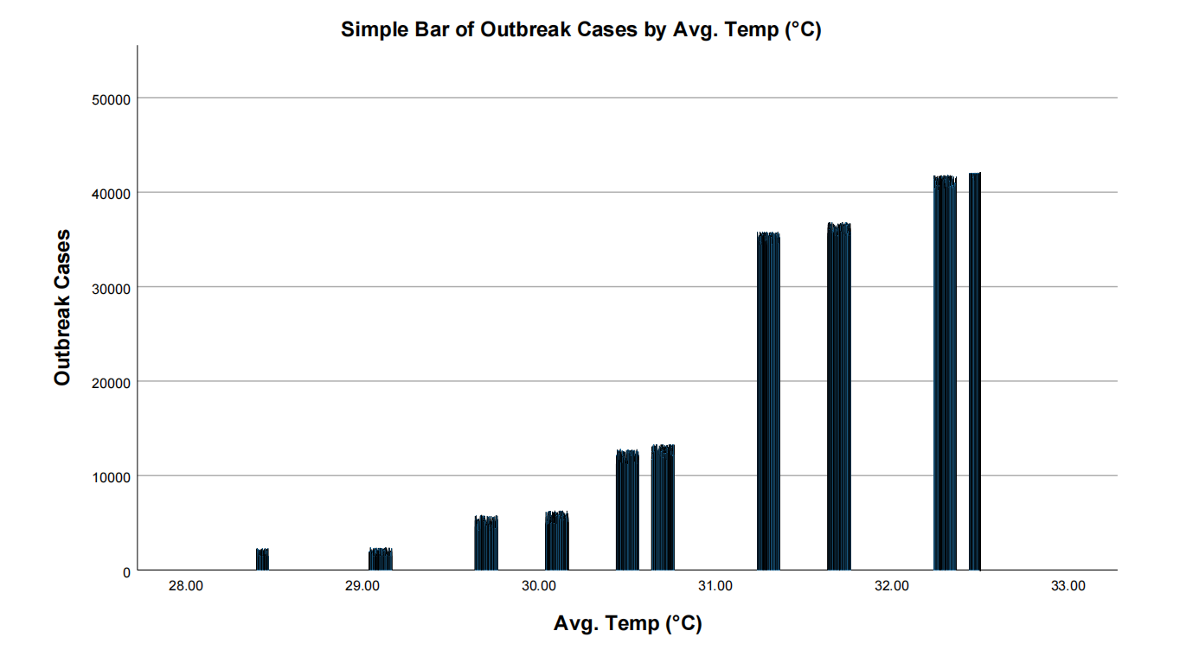

This bar chart shows the relationship between the number of outbreaks with the average temperature of the region. From this chart, the outbreak cases are observed to be increasing with the temperature, which is a sign that increasing temperature has an effect on outbreak cases.

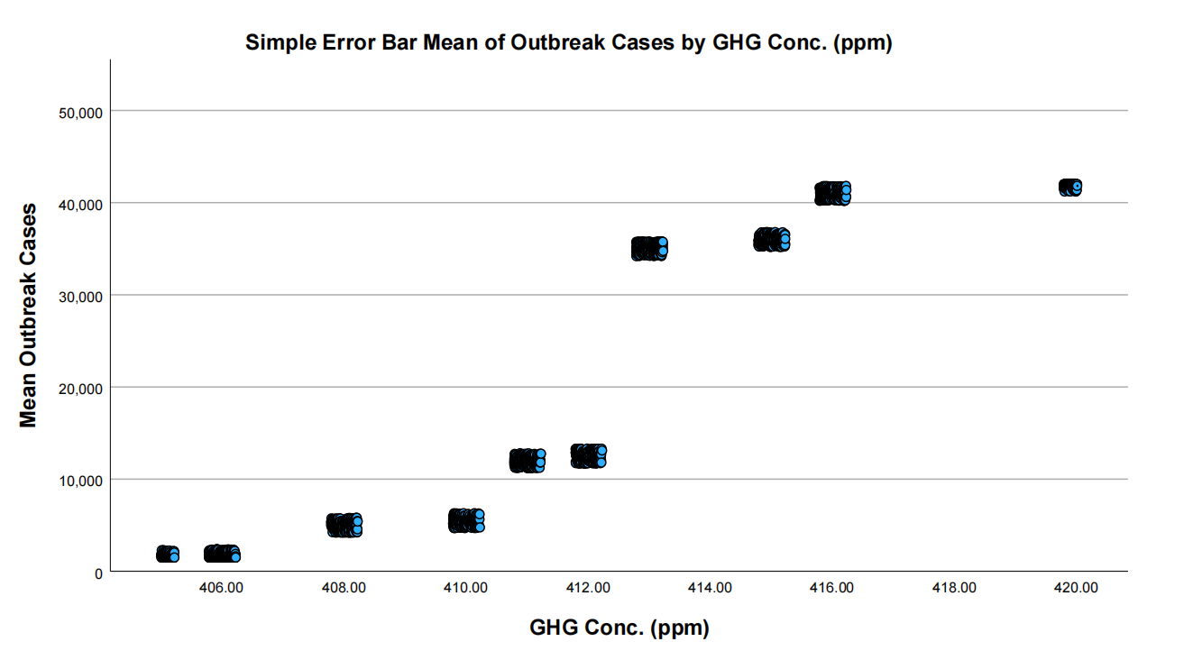

In this visualization, we are seeing the concentration of greenhouse gas emissions in each year. This also appears to be increasing in the region, showing a positive correlation. The error bar shows a 95% confidence interval, some calculations yielded infinite values and were then removed.

Greenhouse gases are characteristics of industrialization as most industries release these dangerous gases into the atmosphere which then reacts with the ozone layer causing depletion. The depletion of the ozone layer leads to increase in average temperature and exposure of humans to radiations which may cause some genetic changes in the way the body responds to disease (immunity).



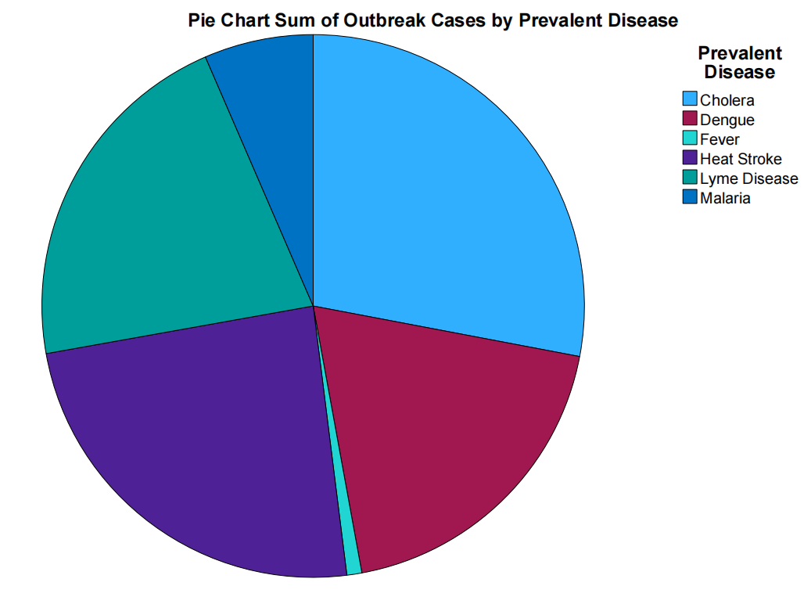

The pie chart shows the outbreak cases by their prevalent diseases. Looking at the visual, we were made to understand that the most common disease in the region was Malaria followed by; Lyme disease, Heat stroke and others. Using the pie chart visualization, it helped to clearly see the level of prevalence of each disease recorded in the region in order of magnitude.

|  |  |  |  |  |  |  |  |
| --- | --- | --- | --- | --- | --- | --- | --- |
| **Correlations** | | | | | | | |
|  | | | | | | | |
|  | | Avg. Temp (°C) | Rainfall (mm) | Outbreak Cases | Mortality Rate (%) | GHG Conc. (ppm) | Deforestation Rate (%) |
| Avg. Temp (°C) | Pearson Correlation | 1 | -.990** | .937** | .337** | .978** | .205** |
| Sig. (2-tailed) |  | <.001 | <.001 | <.001 | <.001 | <.001 |
| N | 2500 | 2500 | 2500 | 2500 | 2500 | 2500 |
| Rainfall (mm) | Pearson Correlation | -.990** | 1 | -.969** | -.307** | -.972** | -.180** |
| Sig. (2-tailed) | <.001 |  | <.001 | <.001 | <.001 | <.001 |
| N | 2500 | 2500 | 2500 | 2500 | 2500 | 2500 |
| Outbreak Cases | Pearson Correlation | .937** | -.969** | 1 | .193** | .916** | .204** |
| Sig. (2-tailed) | <.001 | <.001 |  | <.001 | <.001 | <.001 |
| N | 2500 | 2500 | 2500 | 2500 | 2500 | 2500 |
| Mortality Rate (%) | Pearson Correlation | .337** | -.307** | .193** | 1 | .358** | .410** |
| Sig. (2-tailed) | <.001 | <.001 | <.001 |  | <.001 | <.001 |
| N | 2500 | 2500 | 2500 | 2500 | 2500 | 2500 |
| GHG Conc. (ppm) | Pearson Correlation | .978** | -.972** | .916** | .358** | 1 | .163** |
| Sig. (2-tailed) | <.001 | <.001 | <.001 | <.001 |  | <.001 |
| N | 2500 | 2500 | 2500 | 2500 | 2500 | 2500 |
| Deforestation Rate (%) | Pearson Correlation | .205** | -.180** | .204** | .410** | .163** | 1 |
| Sig. (2-tailed) | <.001 | <.001 | <.001 | <.001 | <.001 |  |
| N | 2500 | 2500 | 2500 | 2500 | 2500 | 2500 |
| **. Correlation is significant at the 0.01 level (2-tailed). | | | | | | | |

From this corelation table, it can be deducted that;

* There is a strong positive correlation between Temperature and Outbreak cases (r= 0.937). Meaning that higher temperatures lead to more outbreak cases.
* There is a strong positive correlation between GHG conc. and outbreak cases (r = 0.916). Meaning that the higher the level of greenhouse gases, the higher the outbreak rates of diseases.
* There is a moderately positive correlation between deforestation (r = 0.204)
* There was a strong negative correlation between rainfall and outbreak cases (r = -0.969)
* There was a weak positive correlation between outbreak cases and mortality rate (r = 0.193) meaning that outbreak cases do not always directly correlate to death.

And the others.

REGRESSION

The method used for regression was linear regression.

|  |  |  |  |
| --- | --- | --- | --- |
| **Variables Entered/Removeda** | | | |
| Model | Variables Entered | Variables Removed | Method |
| 1 | Avg. Temp (°C), Deforestation Rate (%), GHG Conc. (ppm)b | . | Enter |
| a. Dependent Variable: Outbreak Cases | | | |
| b. All requested variables entered. | | | |

|  |  |  |  |  |
| --- | --- | --- | --- | --- |
| **Model Summary** | | | | |
| Model | R | R Square | Adjusted R Square | Std. Error of the Estimate |
| 1 | .937a | .878 | .878 | 5648.755 |
| a. Predictors: (Constant), Avg. Temp (°C), Deforestation Rate (%), GHG Conc. (ppm) | | | | |

The key variables used in this regression are;

Outbreak cases(dependent),

Temperature, GHG conc., and deforestation rate(independent variables)

Observation:

* The R2 = 0.878, this means that 87.8% of the changes in outbreak cases can be explained by these variables.

|  |  |  |  |  |  |  |
| --- | --- | --- | --- | --- | --- | --- |
| **ANOVAa** | | | | | | |
| Model | | Sum of Squares | df | Mean Square | F | Sig. |
| 1 | Regression | 574822577201.474 | 3 | 191607525733.825 | 6004.918 | <.001b |
| Residual | 79643448346.413 | 2496 | 31908432.831 |  |  |
| Total | 654466025547.886 | 2499 |  |  |  |
| a. Dependent Variable: Outbreak Cases | | | | | | |
| b. Predictors: (Constant), Avg. Temp (°C), Deforestation Rate (%), GHG Conc. (ppm) | | | | | | |

|  |  |  |  |  |  |  |
| --- | --- | --- | --- | --- | --- | --- |
| **Coefficientsa** | | | | | | |
| Model | | Unstandardized Coefficients | | Standardized Coefficients | t | Sig. |
| B | Std. Error | Beta |
| 1 | (Constant) | -335167.933 | 38944.597 |  | -8.606 | <.001 |
| GHG Conc. (ppm) | -31.244 | 126.235 | -.008 | -.248 | .805 |
| Deforestation Rate (%) | 258.075 | 162.459 | .012 | 1.589 | .112 |
| Avg. Temp (°C) | 11978.695 | 438.714 | .943 | 27.304 | <.001 |
| a. Dependent Variable: Outbreak Cases | | | | | | |

Under the coefficients, it can be observed that;

* Temperature is the most significant predictor (p < 0.001, and Beta = 0.943); meaning of all the variables used, temperature has the strongest impact.
* GHG conc. (P = 0.805) and deforestation rate (p = 0.112) did not directly affect outbreak cases in the model. In other words, they were insignificant predictors.

TIME SERIES ANALYSIS

|  |  |  |  |
| --- | --- | --- | --- |
| **Model Description** | | | |
|  | | | Model Type |
| Model ID | Outbreak Cases | Model_1 | ARIMA(0,0,0) |
| Mortality Rate (%) | Model_2 | ARIMA(0,0,0) |
| Economic Loss ($M) | Model_3 | ARIMA(0,0,0) |

|  |  |  |  |  |  |  |  |  |  |  |  |  |
| --- | --- | --- | --- | --- | --- | --- | --- | --- | --- | --- | --- | --- |
| **Model Fit** | | | | | | | | | | | | |
| Fit Statistic | Mean | SE | Minimum | Maximum | Percentile | | | | | | | |
| 5 | 10 | 25 | 50 | 75 | 90 | 95 |
| Stationary R-squared | .597 | .298 | .284 | .878 | .284 | .284 | .284 | .629 | .878 | .878 | .878 |
| R-squared | .566 | .356 | .178 | .878 | .178 | .178 | .178 | .643 | .878 | .878 | .878 |
| RMSE | 1883.597 | 3259.502 | .612 | 5647.345 | .612 | .612 | .612 | 2.833 | 5647.345 | 5647.345 | 5647.345 |
| MAPE | 52.711 | 37.876 | 16.033 | 91.681 | 16.033 | 16.033 | 16.033 | 50.419 | 91.681 | 91.681 | 91.681 |
| MaxAPE | 272.478 | 296.748 | 77.117 | 613.952 | 77.117 | 77.117 | 77.117 | 126.366 | 613.952 | 613.952 | 613.952 |
| MAE | 1595.095 | 2760.542 | .556 | 4782.694 | .556 | .556 | .556 | 2.034 | 4782.694 | 4782.694 | 4782.694 |
| MaxAE | 3327.712 | 5755.994 | 1.122 | 9974.160 | 1.122 | 1.122 | 1.122 | 7.853 | 9974.160 | 9974.160 | 9974.160 |
| Normalized BIC | 6.139 | 9.776 | -.968 | 17.287 | -.968 | -.968 | -.968 | 2.098 | 17.287 | 17.287 | 17.287 |

|  |  |  |  |  |  |  |
| --- | --- | --- | --- | --- | --- | --- |
| **Model Statistics** | | | | | | |
| Model | Number of Predictors | Model Fit statistics | Ljung-Box Q(18) | | | Number of Outliers |
| Stationary R-squared | Statistics | DF | Sig. |
| Outbreak Cases-Model_1 | 1 | .878 | 13.017 | 18 | .791 | <.001 |
| Mortality Rate (%)-Model_2 | 3 | .284 | 23.748 | 18 | .163 | <.001 |
| Economic Loss ($M)-Model_3 | 4 | .629 | 10.018 | 18 | .931 | <.001 |

Observation from the time series model:

* The ARIMA (0,0,0) model was used to predict future outbreak cases, mortality rate, and economic loss based on the dataset.
* It stands for **AutoRegressive(AR)** which had 0 – meaning no past values were used to predict future values. **Intergrated (I)** had 0 – meaning no differencing was applied to make the series stationary. **Moving Average (MA)** had 0 – meaning no past forecast errors are used to improve future predictions.

**CHAPTER 5: CONCLUSION**

From this experiment, from all the analysis and visualizations carried out, it was discovered that human actions are the major drivers of climate change. Through greenhouse gas emissions and deforestation, improper disposal of waste and many others. These actions have led to the destruction and deterioration of the earth and the protection it offers humanity.

These combination deflections in the normal properties of the earth such as; increased average temperature, rising ocean levels, depletion of the ozone layer and many others has led to what is now called “Climate Change”.

In this research, the effects of climate change on the outbreak of infectious disease were studied and it was shown to have a perfect positive relationship.

Climate change, having different relations with different factors, have in one way or another affected the outbreak of diseases in humans. It has been scientifically proven that the ultraviolet radiation from the sun, when exposed to it unprotected and for a long time can even cause mutations in humans.

In conclusion, climate change has increased the severity and numbers of infectious diseases in living organisms and it will continue to do so if appropriate measures are not taken to curb the human activities that are driving this monstrosity.

Plans need to be put in place to; cut down the use of fossil fuels as these are the major contributors to the concentration of greenhouse gases in the atmosphere, encourage afforestation in all areas and also make use of sustainable practices in the manufacturing industries.

People should also be educated on the effects of their actions on the environment and how that can lead to infectious diseases.

REFRENCES:

1. Climate Change and Infectious Diseases: A Review of Evidence and Future Directions – ***Luis M. Escobar, Ryan R. Stewart***
2. The Impact of Increasing Temperatures due to Climate Change on Infectious Diseases – Published in: ***The BMJ. – Alistair Woodward,, Simon Hales and Phillip Weinstein.***
3. Essential Biology for Senior Secondary Schools –  ***E.J Simon, Neil Campbell.***
4. Impact of Climate Change on Infectious Disease”. Biological threat and Countermeasure Centre for Military Institute of Hygiene and Epidemiology. Lubelska, 2, 24-100 Pulawy, Poland. - ***Thomas Mirski and Michal Bartoszcze***
5. Quantitative Data Analysis with SPSS: A Guide for Social Sciences – ***Alan Bryman, DuncanCramer***
6. Data Analysis with IBM SPSS Statistics – ***Kenneth Stehilk-Barry and Anthony J. Babinec.***